Login

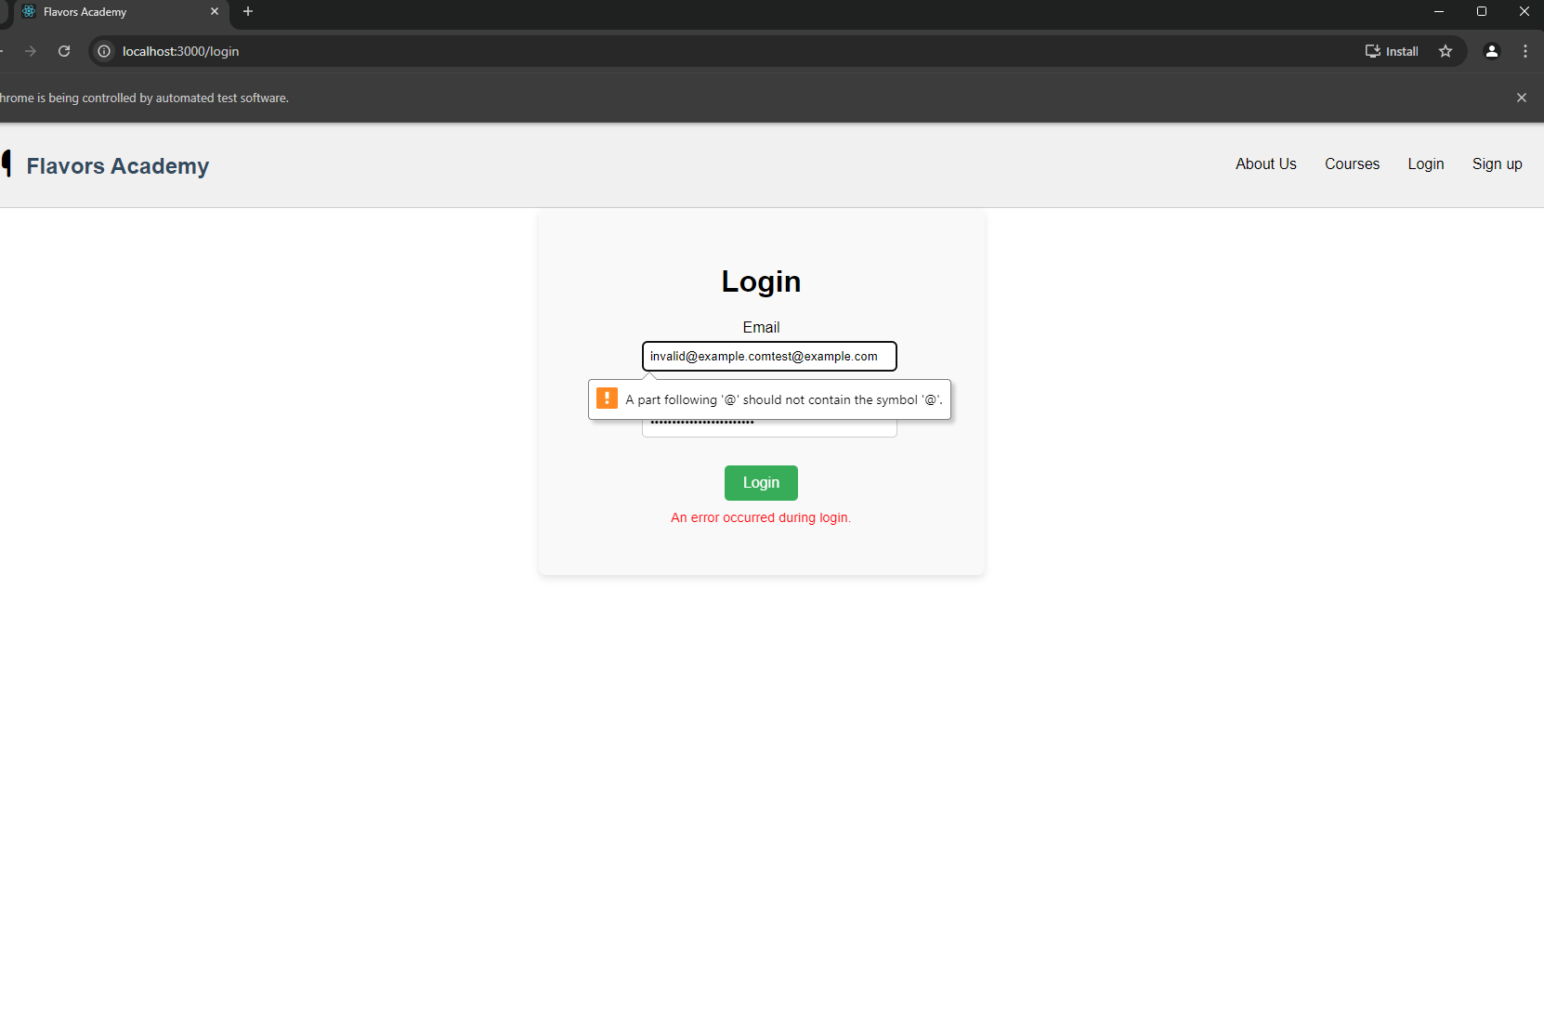

C:\CourseWork\code\flavors-academy-local\Testing\TestingFrontend>python test_login.py

DevTools listening on ws://127.0.0.1:49859/devtools/browser/33a31c36-54bb-48cc-bf4b-a4e14ce32cac

.F[18396:6980:1119/184633.443:ERROR:device_event_log_impl.cc(201)] [18:46:33.443] USB: usb_service_win.cc:105 SetupDiGetDeviceProperty({{A45C254E-DF1C-4EFD-8020-67D146A850E0}, 6}) failed: Element not found. (0x490)

Created TensorFlow Lite XNNPACK delegate for CPU.

F

======================================================================

FAIL: test_login_failure (__main__.TestLoginComponent.test_login_failure)

----------------------------------------------------------------------

Traceback (most recent call last):

File "C:\CourseWork\code\flavors-academy-local\Testing\TestingFrontend\test_login.py", line 60, in test_login_failure

self.assertIn("Invalid email or password", error_message.text)

AssertionError: 'Invalid email or password' not found in 'An error occurred during login.'

======================================================================

FAIL: test_login_success (__main__.TestLoginComponent.test_login_success)

----------------------------------------------------------------------

Traceback (most recent call last):

File "C:\CourseWork\code\flavors-academy-local\Testing\TestingFrontend\test_login.py", line 31, in test_login_success

WebDriverWait(driver, 20).until(

File "C:\Users\Nishat.Sultana\AppData\Local\Packages\PythonSoftwareFoundation.Python.3.12_qbz5n2kfra8p0\LocalCache\local-packages\Python312\site-packages\selenium\webdriver\support\wait.py", line 105, in until

raise TimeoutException(message, screen, stacktrace)

selenium.common.exceptions.TimeoutException: Message:

During handling of the above exception, another exception occurred:

Traceback (most recent call last):

File "C:\CourseWork\code\flavors-academy-local\Testing\TestingFrontend\test_login.py", line 37, in test_login_success

self.fail("Login redirection timed out - login may have failed or URL did not redirect as expected.")

AssertionError: Login redirection timed out - login may have failed or URL did not redirect as expected.

----------------------------------------------------------------------

Ran 3 tests in 28.217s

FAILED (failures=2)

Signup

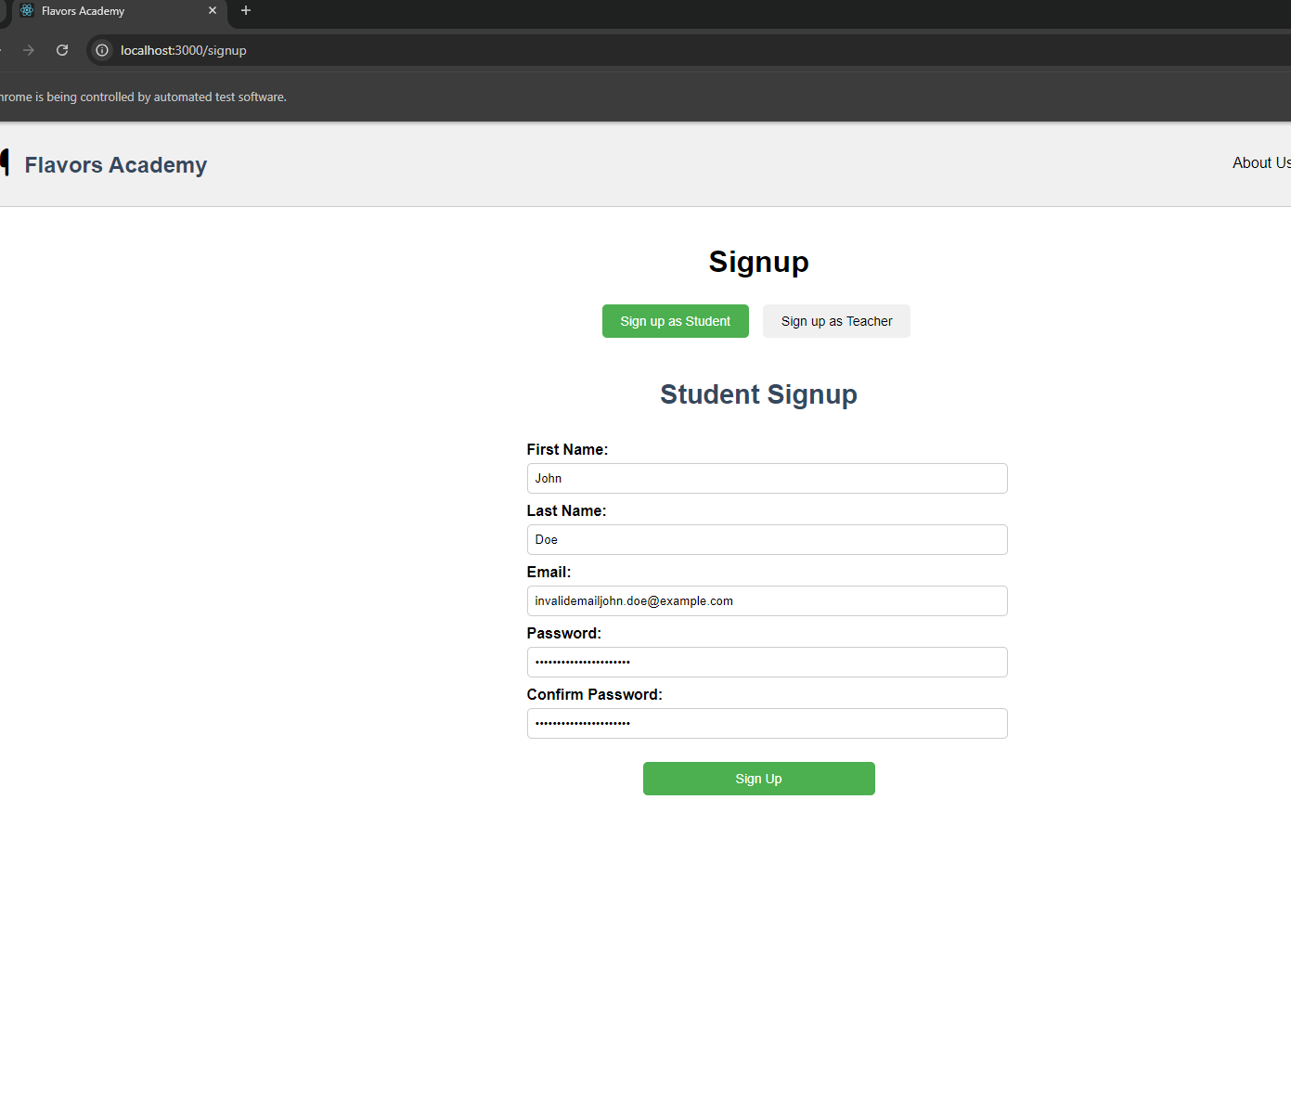

C:\CourseWork\code\flavors-academy-local\Testing\TestingFrontend>python test_signup.py

DevTools listening on ws://127.0.0.1:49969/devtools/browser/e4db7682-dee3-4a6d-9caf-a53358f4e74c

[21952:24236:1119/184851.940:ERROR:device_event_log_impl.cc(201)] [18:48:51.940] USB: usb_service_win.cc:105 SetupDiGetDeviceProperty({{A45C254E-DF1C-4EFD-8020-67D146A850E0}, 6}) failed: Element not found. (0x490)

Created TensorFlow Lite XNNPACK delegate for CPU.

Error messages found: []

F.F.

======================================================================

FAIL: test_email_validation (__main__.TestSignupComponent.test_email_validation)

----------------------------------------------------------------------

Traceback (most recent call last):

File "C:\CourseWork\code\flavors-academy-local\Testing\TestingFrontend\test_signup.py", line 46, in test_email_validation

email_error = WebDriverWait(driver, 10).until(

^^^^^^^^^^^^^^^^^^^^^^^^^^^^^^^^

File "C:\Users\Nishat.Sultana\AppData\Local\Packages\PythonSoftwareFoundation.Python.3.12_qbz5n2kfra8p0\LocalCache\local-packages\Python312\site-packages\selenium\webdriver\support\wait.py", line 105, in until

raise TimeoutException(message, screen, stacktrace)

selenium.common.exceptions.TimeoutException: Message:

Stacktrace:

GetHandleVerifier [0x003533E3+25059]

(No symbol) [0x002DCDE4]

(No symbol) [0x001BBEC3]

(No symbol) [0x001FFD86]

(No symbol) [0x001FFFCB]

(No symbol) [0x0023D952]

(No symbol) [0x00221F44]

(No symbol) [0x0023B51E]

(No symbol) [0x00221C96]

(No symbol) [0x001F3FAC]

(No symbol) [0x001F4F3D]

GetHandleVerifier [0x00645543+3113795]

GetHandleVerifier [0x0065A20A+3198986]

GetHandleVerifier [0x006529E2+3168226]

GetHandleVerifier [0x003F3250+680016]

(No symbol) [0x002E572D]

(No symbol) [0x002E29D8]

(No symbol) [0x002E2B75]

(No symbol) [0x002D57D0]

BaseThreadInitThunk [0x76BE7BA9+25]

RtlInitializeExceptionChain [0x77D2C0CB+107]

RtlClearBits [0x77D2C04F+191]

During handling of the above exception, another exception occurred:

Traceback (most recent call last):

File "C:\CourseWork\code\flavors-academy-local\Testing\TestingFrontend\test_signup.py", line 55, in test_email_validation

self.fail("Email validation error message did not appear as expected.")

AssertionError: Email validation error message did not appear as expected.

======================================================================

FAIL: test_successful_signup (__main__.TestSignupComponent.test_successful_signup)

----------------------------------------------------------------------

Traceback (most recent call last):

File "C:\CourseWork\code\flavors-academy-local\Testing\TestingFrontend\test_signup.py", line 95, in test_successful_signup

success_toast = WebDriverWait(driver, 10).until(

^^^^^^^^^^^^^^^^^^^^^^^^^^^^^^^^

File "C:\Users\Nishat.Sultana\AppData\Local\Packages\PythonSoftwareFoundation.Python.3.12_qbz5n2kfra8p0\LocalCache\local-packages\Python312\site-packages\selenium\webdriver\support\wait.py", line 105, in until

raise TimeoutException(message, screen, stacktrace)

selenium.common.exceptions.TimeoutException: Message:

Stacktrace:

GetHandleVerifier [0x003533E3+25059]

(No symbol) [0x002DCDE4]

(No symbol) [0x001BBEC3]

(No symbol) [0x001FFD86]

(No symbol) [0x001FFFCB]

(No symbol) [0x0023D952]

(No symbol) [0x00221F44]

(No symbol) [0x0023B51E]

(No symbol) [0x00221C96]

(No symbol) [0x001F3FAC]

(No symbol) [0x001F4F3D]

GetHandleVerifier [0x00645543+3113795]

GetHandleVerifier [0x0065A20A+3198986]

GetHandleVerifier [0x006529E2+3168226]

GetHandleVerifier [0x003F3250+680016]

(No symbol) [0x002E572D]

(No symbol) [0x002E29D8]

(No symbol) [0x002E2B75]

(No symbol) [0x002D57D0]

BaseThreadInitThunk [0x76BE7BA9+25]

RtlInitializeExceptionChain [0x77D2C0CB+107]

RtlClearBits [0x77D2C04F+191]

During handling of the above exception, another exception occurred:

Traceback (most recent call last):

File "C:\CourseWork\code\flavors-academy-local\Testing\TestingFrontend\test_signup.py", line 100, in test_successful_signup

self.fail("Success toast did not appear - signup may have failed.")

AssertionError: Success toast did not appear - signup may have failed.

----------------------------------------------------------------------

Ran 4 tests in 28.325s

FAILED (failures=2)

Student dashboard

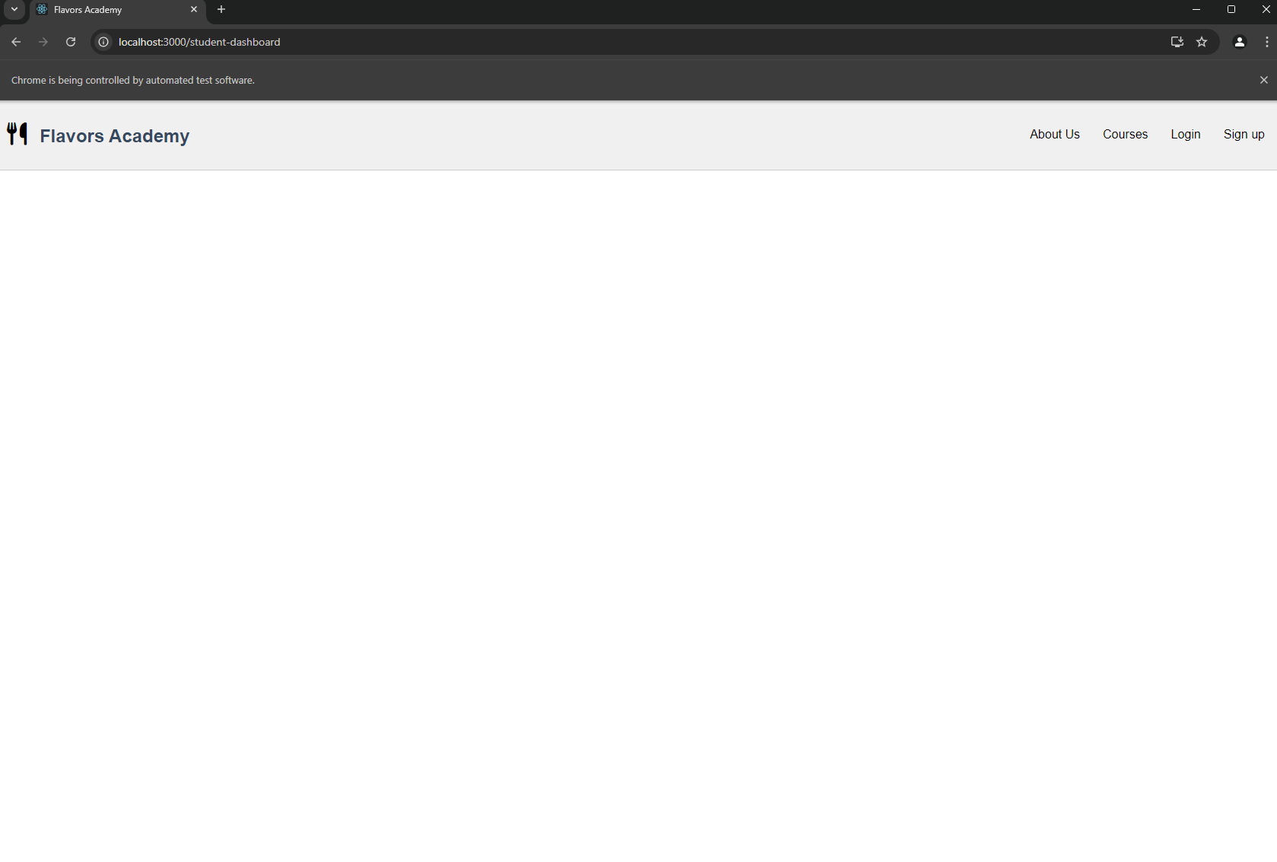

C:\CourseWork\code\flavors-academy-local\Testing\TestingFrontend>python test_signup.py

DevTools listening on ws://127.0.0.1:49969/devtools/browser/e4db7682-dee3-4a6d-9caf-a53358f4e74c

[21952:24236:1119/184851.940:ERROR:device_event_log_impl.cc(201)] [18:48:51.940] USB: usb_service_win.cc:105 SetupDiGetDeviceProperty({{A45C254E-DF1C-4EFD-8020-67D146A850E0}, 6}) failed: Element not found. (0x490)

Created TensorFlow Lite XNNPACK delegate for CPU.

Error messages found: []

F.F.

======================================================================

FAIL: test_email_validation (__main__.TestSignupComponent.test_email_validation)

----------------------------------------------------------------------

Traceback (most recent call last):

File "C:\CourseWork\code\flavors-academy-local\Testing\TestingFrontend\test_signup.py", line 46, in test_email_validation

email_error = WebDriverWait(driver, 10).until(

^^^^^^^^^^^^^^^^^^^^^^^^^^^^^^^^

File "C:\Users\Nishat.Sultana\AppData\Local\Packages\PythonSoftwareFoundation.Python.3.12_qbz5n2kfra8p0\LocalCache\local-packages\Python312\site-packages\selenium\webdriver\support\wait.py", line 105, in until

raise TimeoutException(message, screen, stacktrace)

selenium.common.exceptions.TimeoutException: Message:

Stacktrace:

GetHandleVerifier [0x003533E3+25059]

(No symbol) [0x002DCDE4]

(No symbol) [0x001BBEC3]

(No symbol) [0x001FFD86]

(No symbol) [0x001FFFCB]

(No symbol) [0x0023D952]

(No symbol) [0x00221F44]

(No symbol) [0x0023B51E]

(No symbol) [0x00221C96]

(No symbol) [0x001F3FAC]

(No symbol) [0x001F4F3D]

GetHandleVerifier [0x00645543+3113795]

GetHandleVerifier [0x0065A20A+3198986]

GetHandleVerifier [0x006529E2+3168226]

GetHandleVerifier [0x003F3250+680016]

(No symbol) [0x002E572D]

(No symbol) [0x002E29D8]

(No symbol) [0x002E2B75]

(No symbol) [0x002D57D0]

BaseThreadInitThunk [0x76BE7BA9+25]

RtlInitializeExceptionChain [0x77D2C0CB+107]

RtlClearBits [0x77D2C04F+191]

During handling of the above exception, another exception occurred:

Traceback (most recent call last):

File "C:\CourseWork\code\flavors-academy-local\Testing\TestingFrontend\test_signup.py", line 55, in test_email_validation

self.fail("Email validation error message did not appear as expected.")

AssertionError: Email validation error message did not appear as expected.

======================================================================

FAIL: test_successful_signup (__main__.TestSignupComponent.test_successful_signup)

----------------------------------------------------------------------

Traceback (most recent call last):

File "C:\CourseWork\code\flavors-academy-local\Testing\TestingFrontend\test_signup.py", line 95, in test_successful_signup

success_toast = WebDriverWait(driver, 10).until(

^^^^^^^^^^^^^^^^^^^^^^^^^^^^^^^^

File "C:\Users\Nishat.Sultana\AppData\Local\Packages\PythonSoftwareFoundation.Python.3.12_qbz5n2kfra8p0\LocalCache\local-packages\Python312\site-packages\selenium\webdriver\support\wait.py", line 105, in until

raise TimeoutException(message, screen, stacktrace)

selenium.common.exceptions.TimeoutException: Message:

Stacktrace:

GetHandleVerifier [0x003533E3+25059]

(No symbol) [0x002DCDE4]

(No symbol) [0x001BBEC3]

(No symbol) [0x001FFD86]

(No symbol) [0x001FFFCB]

(No symbol) [0x0023D952]

(No symbol) [0x00221F44]

(No symbol) [0x0023B51E]

(No symbol) [0x00221C96]

(No symbol) [0x001F3FAC]

(No symbol) [0x001F4F3D]

GetHandleVerifier [0x00645543+3113795]

GetHandleVerifier [0x0065A20A+3198986]

GetHandleVerifier [0x006529E2+3168226]

GetHandleVerifier [0x003F3250+680016]

(No symbol) [0x002E572D]

(No symbol) [0x002E29D8]

(No symbol) [0x002E2B75]

(No symbol) [0x002D57D0]

BaseThreadInitThunk [0x76BE7BA9+25]

RtlInitializeExceptionChain [0x77D2C0CB+107]

RtlClearBits [0x77D2C04F+191]

During handling of the above exception, another exception occurred:

Traceback (most recent call last):

File "C:\CourseWork\code\flavors-academy-local\Testing\TestingFrontend\test_signup.py", line 100, in test_successful_signup

self.fail("Success toast did not appear - signup may have failed.")

AssertionError: Success toast did not appear - signup may have failed.

----------------------------------------------------------------------

Ran 4 tests in 28.325s

FAILED (failures=2)

C:\CourseWork\code\flavors-academy-local\Testing\TestingFrontend>python test_student_enroll.py

DevTools listening on ws://127.0.0.1:50108/devtools/browser/a419ce84-0868-45c5-8847-a10d161fa6c2

EEEE

======================================================================

ERROR: test_already_enrolled (__main__.TestEnrollPageComponent.test_already_enrolled)

----------------------------------------------------------------------

Traceback (most recent call last):

File "C:\Program Files\WindowsApps\PythonSoftwareFoundation.Python.3.12_3.12.2032.0_x64__qbz5n2kfra8p0\Lib\unittest\mock.py", line 1392, in patched

with self.decoration_helper(patched,

^^^^^^^^^^^^^^^^^^^^^^^^^^^^^^^

File "C:\Program Files\WindowsApps\PythonSoftwareFoundation.Python.3.12_3.12.2032.0_x64__qbz5n2kfra8p0\Lib\contextlib.py", line 137, in __enter__

return next(self.gen)

^^^^^^^^^^^^^^

File "C:\Program Files\WindowsApps\PythonSoftwareFoundation.Python.3.12_3.12.2032.0_x64__qbz5n2kfra8p0\Lib\unittest\mock.py", line 1374, in decoration_helper

arg = exit_stack.enter_context(patching)

^^^^^^^^^^^^^^^^^^^^^^^^^^^^^^^^^^

File "C:\Program Files\WindowsApps\PythonSoftwareFoundation.Python.3.12_3.12.2032.0_x64__qbz5n2kfra8p0\Lib\contextlib.py", line 526, in enter_context

result = _enter(cm)

^^^^^^^^^^

File "C:\Program Files\WindowsApps\PythonSoftwareFoundation.Python.3.12_3.12.2032.0_x64__qbz5n2kfra8p0\Lib\unittest\mock.py", line 1447, in __enter__

self.target = self.getter()

^^^^^^^^^^^^^

File "C:\Program Files\WindowsApps\PythonSoftwareFoundation.Python.3.12_3.12.2032.0_x64__qbz5n2kfra8p0\Lib\pkgutil.py", line 513, in resolve_name

mod = importlib.import_module(modname)

^^^^^^^^^^^^^^^^^^^^^^^^^^^^^^^^

File "C:\Program Files\WindowsApps\PythonSoftwareFoundation.Python.3.12_3.12.2032.0_x64__qbz5n2kfra8p0\Lib\importlib\__init__.py", line 90, in import_module

return _bootstrap._gcd_import(name[level:], package, level)

^^^^^^^^^^^^^^^^^^^^^^^^^^^^^^^^^^^^^^^^^^^^^^^^^^^^

File "<frozen importlib._bootstrap>", line 1387, in _gcd_import

File "<frozen importlib._bootstrap>", line 1360, in _find_and_load

File "<frozen importlib._bootstrap>", line 1324, in _find_and_load_unlocked

ModuleNotFoundError: No module named 'apiService'

======================================================================

ERROR: test_enrollment_failure (__main__.TestEnrollPageComponent.test_enrollment_failure)

----------------------------------------------------------------------

Traceback (most recent call last):

File "C:\Program Files\WindowsApps\PythonSoftwareFoundation.Python.3.12_3.12.2032.0_x64__qbz5n2kfra8p0\Lib\unittest\mock.py", line 1392, in patched

with self.decoration_helper(patched,

^^^^^^^^^^^^^^^^^^^^^^^^^^^^^^^

File "C:\Program Files\WindowsApps\PythonSoftwareFoundation.Python.3.12_3.12.2032.0_x64__qbz5n2kfra8p0\Lib\contextlib.py", line 137, in __enter__

return next(self.gen)

^^^^^^^^^^^^^^

File "C:\Program Files\WindowsApps\PythonSoftwareFoundation.Python.3.12_3.12.2032.0_x64__qbz5n2kfra8p0\Lib\unittest\mock.py", line 1374, in decoration_helper

arg = exit_stack.enter_context(patching)

^^^^^^^^^^^^^^^^^^^^^^^^^^^^^^^^^^

File "C:\Program Files\WindowsApps\PythonSoftwareFoundation.Python.3.12_3.12.2032.0_x64__qbz5n2kfra8p0\Lib\contextlib.py", line 526, in enter_context

result = _enter(cm)

^^^^^^^^^^

File "C:\Program Files\WindowsApps\PythonSoftwareFoundation.Python.3.12_3.12.2032.0_x64__qbz5n2kfra8p0\Lib\unittest\mock.py", line 1447, in __enter__

self.target = self.getter()

^^^^^^^^^^^^^

File "C:\Program Files\WindowsApps\PythonSoftwareFoundation.Python.3.12_3.12.2032.0_x64__qbz5n2kfra8p0\Lib\pkgutil.py", line 513, in resolve_name

mod = importlib.import_module(modname)

^^^^^^^^^^^^^^^^^^^^^^^^^^^^^^^^

File "C:\Program Files\WindowsApps\PythonSoftwareFoundation.Python.3.12_3.12.2032.0_x64__qbz5n2kfra8p0\Lib\importlib\__init__.py", line 90, in import_module

return _bootstrap._gcd_import(name[level:], package, level)

^^^^^^^^^^^^^^^^^^^^^^^^^^^^^^^^^^^^^^^^^^^^^^^^^^^^

File "<frozen importlib._bootstrap>", line 1387, in _gcd_import

File "<frozen importlib._bootstrap>", line 1360, in _find_and_load

File "<frozen importlib._bootstrap>", line 1324, in _find_and_load_unlocked

ModuleNotFoundError: No module named 'apiService'

======================================================================

ERROR: test_load_course_content (__main__.TestEnrollPageComponent.test_load_course_content)

----------------------------------------------------------------------

Traceback (most recent call last):

File "C:\Program Files\WindowsApps\PythonSoftwareFoundation.Python.3.12_3.12.2032.0_x64__qbz5n2kfra8p0\Lib\unittest\mock.py", line 1392, in patched

with self.decoration_helper(patched,

^^^^^^^^^^^^^^^^^^^^^^^^^^^^^^^

File "C:\Program Files\WindowsApps\PythonSoftwareFoundation.Python.3.12_3.12.2032.0_x64__qbz5n2kfra8p0\Lib\contextlib.py", line 137, in __enter__

return next(self.gen)

^^^^^^^^^^^^^^

File "C:\Program Files\WindowsApps\PythonSoftwareFoundation.Python.3.12_3.12.2032.0_x64__qbz5n2kfra8p0\Lib\unittest\mock.py", line 1374, in decoration_helper

arg = exit_stack.enter_context(patching)

^^^^^^^^^^^^^^^^^^^^^^^^^^^^^^^^^^

File "C:\Program Files\WindowsApps\PythonSoftwareFoundation.Python.3.12_3.12.2032.0_x64__qbz5n2kfra8p0\Lib\contextlib.py", line 526, in enter_context

result = _enter(cm)

^^^^^^^^^^

File "C:\Program Files\WindowsApps\PythonSoftwareFoundation.Python.3.12_3.12.2032.0_x64__qbz5n2kfra8p0\Lib\unittest\mock.py", line 1447, in __enter__

self.target = self.getter()

^^^^^^^^^^^^^

File "C:\Program Files\WindowsApps\PythonSoftwareFoundation.Python.3.12_3.12.2032.0_x64__qbz5n2kfra8p0\Lib\pkgutil.py", line 513, in resolve_name

mod = importlib.import_module(modname)

^^^^^^^^^^^^^^^^^^^^^^^^^^^^^^^^

File "C:\Program Files\WindowsApps\PythonSoftwareFoundation.Python.3.12_3.12.2032.0_x64__qbz5n2kfra8p0\Lib\importlib\__init__.py", line 90, in import_module

return _bootstrap._gcd_import(name[level:], package, level)

^^^^^^^^^^^^^^^^^^^^^^^^^^^^^^^^^^^^^^^^^^^^^^^^^^^^

File "<frozen importlib._bootstrap>", line 1387, in _gcd_import

File "<frozen importlib._bootstrap>", line 1360, in _find_and_load

File "<frozen importlib._bootstrap>", line 1324, in _find_and_load_unlocked

ModuleNotFoundError: No module named 'apiService'

======================================================================

ERROR: test_successful_enrollment (__main__.TestEnrollPageComponent.test_successful_enrollment)

----------------------------------------------------------------------

Traceback (most recent call last):

File "C:\Program Files\WindowsApps\PythonSoftwareFoundation.Python.3.12_3.12.2032.0_x64__qbz5n2kfra8p0\Lib\unittest\mock.py", line 1392, in patched

with self.decoration_helper(patched,

^^^^^^^^^^^^^^^^^^^^^^^^^^^^^^^

File "C:\Program Files\WindowsApps\PythonSoftwareFoundation.Python.3.12_3.12.2032.0_x64__qbz5n2kfra8p0\Lib\contextlib.py", line 137, in __enter__

return next(self.gen)

^^^^^^^^^^^^^^

File "C:\Program Files\WindowsApps\PythonSoftwareFoundation.Python.3.12_3.12.2032.0_x64__qbz5n2kfra8p0\Lib\unittest\mock.py", line 1374, in decoration_helper

arg = exit_stack.enter_context(patching)

^^^^^^^^^^^^^^^^^^^^^^^^^^^^^^^^^^

File "C:\Program Files\WindowsApps\PythonSoftwareFoundation.Python.3.12_3.12.2032.0_x64__qbz5n2kfra8p0\Lib\contextlib.py", line 526, in enter_context

result = _enter(cm)

^^^^^^^^^^

File "C:\Program Files\WindowsApps\PythonSoftwareFoundation.Python.3.12_3.12.2032.0_x64__qbz5n2kfra8p0\Lib\unittest\mock.py", line 1447, in __enter__

self.target = self.getter()

^^^^^^^^^^^^^

File "C:\Program Files\WindowsApps\PythonSoftwareFoundation.Python.3.12_3.12.2032.0_x64__qbz5n2kfra8p0\Lib\pkgutil.py", line 513, in resolve_name

mod = importlib.import_module(modname)

^^^^^^^^^^^^^^^^^^^^^^^^^^^^^^^^

File "C:\Program Files\WindowsApps\PythonSoftwareFoundation.Python.3.12_3.12.2032.0_x64__qbz5n2kfra8p0\Lib\importlib\__init__.py", line 90, in import_module

return _bootstrap._gcd_import(name[level:], package, level)

^^^^^^^^^^^^^^^^^^^^^^^^^^^^^^^^^^^^^^^^^^^^^^^^^^^^

File "<frozen importlib._bootstrap>", line 1387, in _gcd_import

File "<frozen importlib._bootstrap>", line 1360, in _find_and_load

File "<frozen importlib._bootstrap>", line 1324, in _find_and_load_unlocked

ModuleNotFoundError: No module named 'apiService'

----------------------------------------------------------------------

Ran 4 tests in 7.074s

FAILED (errors=4)

C:\CourseWork\code\flavors-academy-local\Testing\TestingFrontend>python test_student_dashboard.py

DevTools listening on ws://127.0.0.1:50157/devtools/browser/ef105282-a8d2-488a-8d7a-a218ba923eb3

[25992:15636:1119/185054.287:ERROR:device_event_log_impl.cc(201)] [18:50:54.287] USB: usb_service_win.cc:105 SetupDiGetDeviceProperty({{A45C254E-DF1C-4EFD-8020-67D146A850E0}, 6}) failed: Element not found. (0x490)

Created TensorFlow Lite XNNPACK delegate for CPU.

Error in test_course_search_filtering: Message:

Stacktrace:

GetHandleVerifier [0x00007FF7ADAC6CB5+28821]

(No symbol) [0x00007FF7ADA33840]

(No symbol) [0x00007FF7AD8D578A]

(No symbol) [0x00007FF7AD9291BE]

(No symbol) [0x00007FF7AD9294AC]

(No symbol) [0x00007FF7AD972647]

(No symbol) [0x00007FF7AD94F33F]

(No symbol) [0x00007FF7AD96F412]

(No symbol) [0x00007FF7AD94F0A3]

(No symbol) [0x00007FF7AD91A778]

(No symbol) [0x00007FF7AD91B8E1]

GetHandleVerifier [0x00007FF7ADDFFCAD+3408013]

GetHandleVerifier [0x00007FF7ADE1741F+3504127]

GetHandleVerifier [0x00007FF7ADE0B5FD+3455453]

GetHandleVerifier [0x00007FF7ADB8BDBB+835995]

(No symbol) [0x00007FF7ADA3EB5F]

(No symbol) [0x00007FF7ADA3A814]

(No symbol) [0x00007FF7ADA3A9AD]

(No symbol) [0x00007FF7ADA2A199]

BaseThreadInitThunk [0x00007FFBE143259D+29]

RtlUserThreadStart [0x00007FFBE212AF38+40]

F

DevTools listening on ws://127.0.0.1:50206/devtools/browser/15998c4f-fcdd-47a6-be90-1dab2dfa398d

[17372:12892:1119/185118.743:ERROR:device_event_log_impl.cc(201)] [18:51:18.744] USB: usb_service_win.cc:105 SetupDiGetDeviceProperty({{A45C254E-DF1C-4EFD-8020-67D146A850E0}, 6}) failed: Element not found. (0x490)

Created TensorFlow Lite XNNPACK delegate for CPU.

Error in test_fetch_courses_success: Message:

F

DevTools listening on ws://127.0.0.1:50252/devtools/browser/74c7743e-bdb2-4996-81b0-dfe12ff9b2df

[24980:23620:1119/185143.241:ERROR:device_event_log_impl.cc(201)] [18:51:43.242] USB: usb_service_win.cc:105 SetupDiGetDeviceProperty({{A45C254E-DF1C-4EFD-8020-67D146A850E0}, 6}) failed: Element not found. (0x490)

Created TensorFlow Lite XNNPACK delegate for CPU.

Error in test_handle_enroll_click: Message:

Stacktrace:

GetHandleVerifier [0x00007FF7ADAC6CB5+28821]

(No symbol) [0x00007FF7ADA33840]

(No symbol) [0x00007FF7AD8D578A]

(No symbol) [0x00007FF7AD9291BE]

(No symbol) [0x00007FF7AD9294AC]

(No symbol) [0x00007FF7AD972647]

(No symbol) [0x00007FF7AD94F33F]

(No symbol) [0x00007FF7AD96F412]

(No symbol) [0x00007FF7AD94F0A3]

(No symbol) [0x00007FF7AD91A778]

(No symbol) [0x00007FF7AD91B8E1]

GetHandleVerifier [0x00007FF7ADDFFCAD+3408013]

GetHandleVerifier [0x00007FF7ADE1741F+3504127]

GetHandleVerifier [0x00007FF7ADE0B5FD+3455453]

GetHandleVerifier [0x00007FF7ADB8BDBB+835995]

(No symbol) [0x00007FF7ADA3EB5F]

(No symbol) [0x00007FF7ADA3A814]

(No symbol) [0x00007FF7ADA3A9AD]

(No symbol) [0x00007FF7ADA2A199]

BaseThreadInitThunk [0x00007FFBE143259D+29]

RtlUserThreadStart [0x00007FFBE212AF38+40]

F

======================================================================

FAIL: test_course_search_filtering (__main__.TestStudentDashboard.test_course_search_filtering)

Test that the search functionality filters courses correctly.

----------------------------------------------------------------------

Traceback (most recent call last):

File "C:\CourseWork\code\flavors-academy-local\Testing\TestingFrontend\test_student_dashboard.py", line 34, in test_course_search_filtering

search_input = WebDriverWait(self.driver, 20).until(

^^^^^^^^^^^^^^^^^^^^^^^^^^^^^^^^^^^^^

File "C:\Users\Nishat.Sultana\AppData\Local\Packages\PythonSoftwareFoundation.Python.3.12_qbz5n2kfra8p0\LocalCache\local-packages\Python312\site-packages\selenium\webdriver\support\wait.py", line 105, in until

raise TimeoutException(message, screen, stacktrace)

selenium.common.exceptions.TimeoutException: Message:

Stacktrace:

GetHandleVerifier [0x00007FF7ADAC6CB5+28821]

(No symbol) [0x00007FF7ADA33840]

(No symbol) [0x00007FF7AD8D578A]

(No symbol) [0x00007FF7AD9291BE]

(No symbol) [0x00007FF7AD9294AC]

(No symbol) [0x00007FF7AD972647]

(No symbol) [0x00007FF7AD94F33F]

(No symbol) [0x00007FF7AD96F412]

(No symbol) [0x00007FF7AD94F0A3]

(No symbol) [0x00007FF7AD91A778]

(No symbol) [0x00007FF7AD91B8E1]

GetHandleVerifier [0x00007FF7ADDFFCAD+3408013]

GetHandleVerifier [0x00007FF7ADE1741F+3504127]

GetHandleVerifier [0x00007FF7ADE0B5FD+3455453]

GetHandleVerifier [0x00007FF7ADB8BDBB+835995]

(No symbol) [0x00007FF7ADA3EB5F]

(No symbol) [0x00007FF7ADA3A814]

(No symbol) [0x00007FF7ADA3A9AD]

(No symbol) [0x00007FF7ADA2A199]

BaseThreadInitThunk [0x00007FFBE143259D+29]

RtlUserThreadStart [0x00007FFBE212AF38+40]

During handling of the above exception, another exception occurred:

Traceback (most recent call last):

File "C:\CourseWork\code\flavors-academy-local\Testing\TestingFrontend\test_student_dashboard.py", line 47, in test_course_search_filtering

self.fail("Course search filtering did not work as expected.")

AssertionError: Course search filtering did not work as expected.

======================================================================

FAIL: test_fetch_courses_success (__main__.TestStudentDashboard.test_fetch_courses_success)

Test that courses are fetched and displayed successfully on the dashboard.

----------------------------------------------------------------------

Traceback (most recent call last):

File "C:\CourseWork\code\flavors-academy-local\Testing\TestingFrontend\test_student_dashboard.py", line 23, in test_fetch_courses_success

courses = WebDriverWait(self.driver, 20).until(

^^^^^^^^^^^^^^^^^^^^^^^^^^^^^^^^^^^^^

File "C:\Users\Nishat.Sultana\AppData\Local\Packages\PythonSoftwareFoundation.Python.3.12_qbz5n2kfra8p0\LocalCache\local-packages\Python312\site-packages\selenium\webdriver\support\wait.py", line 105, in until

raise TimeoutException(message, screen, stacktrace)

selenium.common.exceptions.TimeoutException: Message:

During handling of the above exception, another exception occurred:

Traceback (most recent call last):

File "C:\CourseWork\code\flavors-academy-local\Testing\TestingFrontend\test_student_dashboard.py", line 29, in test_fetch_courses_success

self.fail("Courses were not displayed on the dashboard.")

AssertionError: Courses were not displayed on the dashboard.

======================================================================

FAIL: test_handle_enroll_click (__main__.TestStudentDashboard.test_handle_enroll_click)

Test that clicking 'Enroll' navigates correctly based on enrollment status.

----------------------------------------------------------------------

Traceback (most recent call last):

File "C:\CourseWork\code\flavors-academy-local\Testing\TestingFrontend\test_student_dashboard.py", line 52, in test_handle_enroll_click

enroll_button = WebDriverWait(self.driver, 20).until(

^^^^^^^^^^^^^^^^^^^^^^^^^^^^^^^^^^^^^

File "C:\Users\Nishat.Sultana\AppData\Local\Packages\PythonSoftwareFoundation.Python.3.12_qbz5n2kfra8p0\LocalCache\local-packages\Python312\site-packages\selenium\webdriver\support\wait.py", line 105, in until

raise TimeoutException(message, screen, stacktrace)

selenium.common.exceptions.TimeoutException: Message:

Stacktrace:

GetHandleVerifier [0x00007FF7ADAC6CB5+28821]

(No symbol) [0x00007FF7ADA33840]

(No symbol) [0x00007FF7AD8D578A]

(No symbol) [0x00007FF7AD9291BE]

(No symbol) [0x00007FF7AD9294AC]

(No symbol) [0x00007FF7AD972647]

(No symbol) [0x00007FF7AD94F33F]

(No symbol) [0x00007FF7AD96F412]

(No symbol) [0x00007FF7AD94F0A3]

(No symbol) [0x00007FF7AD91A778]

(No symbol) [0x00007FF7AD91B8E1]

GetHandleVerifier [0x00007FF7ADDFFCAD+3408013]

GetHandleVerifier [0x00007FF7ADE1741F+3504127]

GetHandleVerifier [0x00007FF7ADE0B5FD+3455453]

GetHandleVerifier [0x00007FF7ADB8BDBB+835995]

(No symbol) [0x00007FF7ADA3EB5F]

(No symbol) [0x00007FF7ADA3A814]

(No symbol) [0x00007FF7ADA3A9AD]

(No symbol) [0x00007FF7ADA2A199]

BaseThreadInitThunk [0x00007FFBE143259D+29]

RtlUserThreadStart [0x00007FFBE212AF38+40]

During handling of the above exception, another exception occurred:

Traceback (most recent call last):

File "C:\CourseWork\code\flavors-academy-local\Testing\TestingFrontend\test_student_dashboard.py", line 64, in test_handle_enroll_click

self.fail("Enrollment navigation did not work as expected.")

AssertionError: Enrollment navigation did not work as expected.

----------------------------------------------------------------------

Ran 3 tests in 78.431s

FAILED (failures=3)

Teacher course

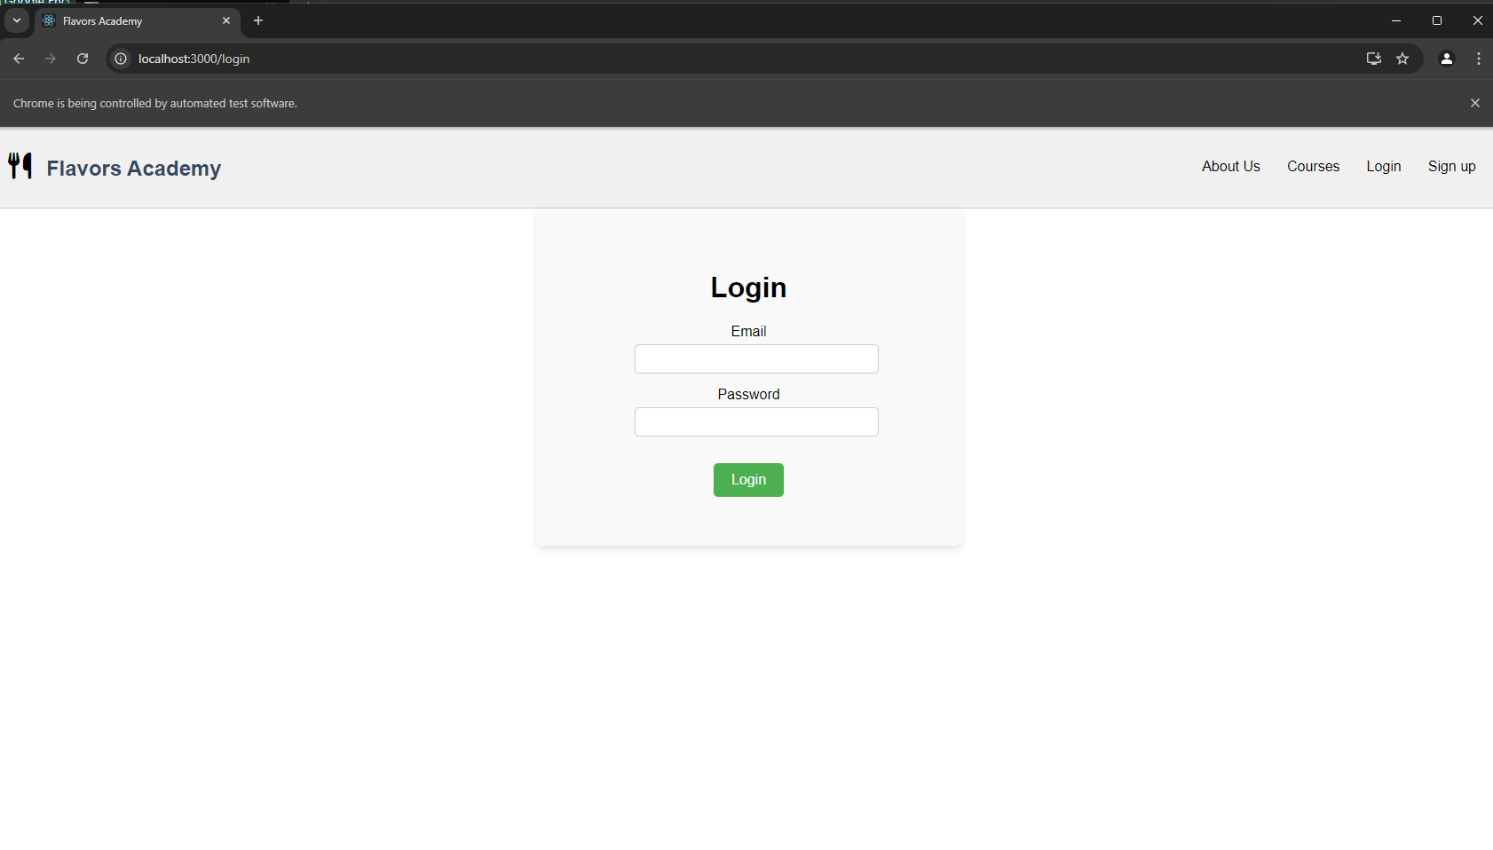

C:\CourseWork\code\flavors-academy-local\Testing\TestingFrontend>python test_teacher_course.py

DevTools listening on ws://127.0.0.1:50337/devtools/browser/2f8ec1d8-8fd2-42f7-b3ce-351ba04b7f40

[25872:9624:1119/185259.934:ERROR:device_event_log_impl.cc(201)] [18:52:59.935] USB: usb_service_win.cc:105 SetupDiGetDeviceProperty({{A45C254E-DF1C-4EFD-8020-67D146A850E0}, 6}) failed: Element not found. (0x490)

Created TensorFlow Lite XNNPACK delegate for CPU.

FFFFRedirected to login page as expected.

.

======================================================================

FAIL: test_click_course_navigates_to_content (__main__.TestCourseComponent.test_click_course_navigates_to_content)

----------------------------------------------------------------------

Traceback (most recent call last):

File "C:\CourseWork\code\flavors-academy-local\Testing\TestingFrontend\test_teacher_course.py", line 99, in test_click_course_navigates_to_content

first_course_link = WebDriverWait(driver, 10).until(

^^^^^^^^^^^^^^^^^^^^^^^^^^^^^^^^

File "C:\Users\Nishat.Sultana\AppData\Local\Packages\PythonSoftwareFoundation.Python.3.12_qbz5n2kfra8p0\LocalCache\local-packages\Python312\site-packages\selenium\webdriver\support\wait.py", line 105, in until

raise TimeoutException(message, screen, stacktrace)

selenium.common.exceptions.TimeoutException: Message:

Stacktrace:

GetHandleVerifier [0x003533E3+25059]

(No symbol) [0x002DCDE4]

(No symbol) [0x001BBEC3]

(No symbol) [0x001FFD86]

(No symbol) [0x001FFFCB]

(No symbol) [0x0023D952]

(No symbol) [0x00221F44]

(No symbol) [0x0023B51E]

(No symbol) [0x00221C96]

(No symbol) [0x001F3FAC]

(No symbol) [0x001F4F3D]

GetHandleVerifier [0x00645543+3113795]

GetHandleVerifier [0x0065A20A+3198986]

GetHandleVerifier [0x006529E2+3168226]

GetHandleVerifier [0x003F3250+680016]

(No symbol) [0x002E572D]

(No symbol) [0x002E29D8]

(No symbol) [0x002E2B75]

(No symbol) [0x002D57D0]

BaseThreadInitThunk [0x76BE7BA9+25]

RtlInitializeExceptionChain [0x77D2C0CB+107]

RtlClearBits [0x77D2C04F+191]

During handling of the above exception, another exception occurred:

Traceback (most recent call last):

File "C:\CourseWork\code\flavors-academy-local\Testing\TestingFrontend\test_teacher_course.py", line 112, in test_click_course_navigates_to_content

self.fail("Failed to navigate to course content page on course selection.")

AssertionError: Failed to navigate to course content page on course selection.

======================================================================

FAIL: test_display_courses_if_available (__main__.TestCourseComponent.test_display_courses_if_available)

----------------------------------------------------------------------

Traceback (most recent call last):

File "C:\CourseWork\code\flavors-academy-local\Testing\TestingFrontend\test_teacher_course.py", line 42, in test_display_courses_if_available

course_list = WebDriverWait(driver, 10).until(

^^^^^^^^^^^^^^^^^^^^^^^^^^^^^^^^

File "C:\Users\Nishat.Sultana\AppData\Local\Packages\PythonSoftwareFoundation.Python.3.12_qbz5n2kfra8p0\LocalCache\local-packages\Python312\site-packages\selenium\webdriver\support\wait.py", line 105, in until

raise TimeoutException(message, screen, stacktrace)

selenium.common.exceptions.TimeoutException: Message:

Stacktrace:

GetHandleVerifier [0x003533E3+25059]

(No symbol) [0x002DCDE4]

(No symbol) [0x001BBEC3]

(No symbol) [0x001FFD86]

(No symbol) [0x001FFFCB]

(No symbol) [0x0023D952]

(No symbol) [0x00221F44]

(No symbol) [0x0023B51E]

(No symbol) [0x00221C96]

(No symbol) [0x001F3FAC]

(No symbol) [0x001F4F3D]

GetHandleVerifier [0x00645543+3113795]

GetHandleVerifier [0x0065A20A+3198986]

GetHandleVerifier [0x006529E2+3168226]

GetHandleVerifier [0x003F3250+680016]

(No symbol) [0x002E572D]

(No symbol) [0x002E29D8]

(No symbol) [0x002E2B75]

(No symbol) [0x002D57D0]

BaseThreadInitThunk [0x76BE7BA9+25]

RtlInitializeExceptionChain [0x77D2C0CB+107]

RtlClearBits [0x77D2C04F+191]

During handling of the above exception, another exception occurred:

Traceback (most recent call last):

File "C:\CourseWork\code\flavors-academy-local\Testing\TestingFrontend\test_teacher_course.py", line 52, in test_display_courses_if_available

self.fail("Courses did not load or display as expected.")

AssertionError: Courses did not load or display as expected.

======================================================================

FAIL: test_error_message_on_fetch_failure (__main__.TestCourseComponent.test_error_message_on_fetch_failure)

----------------------------------------------------------------------

Traceback (most recent call last):

File "C:\CourseWork\code\flavors-academy-local\Testing\TestingFrontend\test_teacher_course.py", line 81, in test_error_message_on_fetch_failure

error_message = WebDriverWait(driver, 10).until(

^^^^^^^^^^^^^^^^^^^^^^^^^^^^^^^^

File "C:\Users\Nishat.Sultana\AppData\Local\Packages\PythonSoftwareFoundation.Python.3.12_qbz5n2kfra8p0\LocalCache\local-packages\Python312\site-packages\selenium\webdriver\support\wait.py", line 105, in until

raise TimeoutException(message, screen, stacktrace)

selenium.common.exceptions.TimeoutException: Message:

Stacktrace:

GetHandleVerifier [0x003533E3+25059]

(No symbol) [0x002DCDE4]

(No symbol) [0x001BBEC3]

(No symbol) [0x001FFD86]

(No symbol) [0x001FFFCB]

(No symbol) [0x0023D952]

(No symbol) [0x00221F44]

(No symbol) [0x0023B51E]

(No symbol) [0x00221C96]

(No symbol) [0x001F3FAC]

(No symbol) [0x001F4F3D]

GetHandleVerifier [0x00645543+3113795]

GetHandleVerifier [0x0065A20A+3198986]

GetHandleVerifier [0x006529E2+3168226]

GetHandleVerifier [0x003F3250+680016]

(No symbol) [0x002E572D]

(No symbol) [0x002E29D8]

(No symbol) [0x002E2B75]

(No symbol) [0x002D57D0]

BaseThreadInitThunk [0x76BE7BA9+25]

RtlInitializeExceptionChain [0x77D2C0CB+107]

RtlClearBits [0x77D2C04F+191]

During handling of the above exception, another exception occurred:

Traceback (most recent call last):

File "C:\CourseWork\code\flavors-academy-local\Testing\TestingFrontend\test_teacher_course.py", line 88, in test_error_message_on_fetch_failure

self.fail("Did not display error message on fetch failure.")

AssertionError: Did not display error message on fetch failure.

======================================================================

FAIL: test_handle_no_courses_message (__main__.TestCourseComponent.test_handle_no_courses_message)

----------------------------------------------------------------------

Traceback (most recent call last):

File "C:\CourseWork\code\flavors-academy-local\Testing\TestingFrontend\test_teacher_course.py", line 63, in test_handle_no_courses_message

no_courses_message = WebDriverWait(driver, 10).until(

^^^^^^^^^^^^^^^^^^^^^^^^^^^^^^^^

File "C:\Users\Nishat.Sultana\AppData\Local\Packages\PythonSoftwareFoundation.Python.3.12_qbz5n2kfra8p0\LocalCache\local-packages\Python312\site-packages\selenium\webdriver\support\wait.py", line 105, in until

raise TimeoutException(message, screen, stacktrace)

selenium.common.exceptions.TimeoutException: Message:

Stacktrace:

GetHandleVerifier [0x003533E3+25059]

(No symbol) [0x002DCDE4]

(No symbol) [0x001BBEC3]

(No symbol) [0x001FFD86]

(No symbol) [0x001FFFCB]

(No symbol) [0x0023D952]

(No symbol) [0x00221F44]

(No symbol) [0x0023B51E]

(No symbol) [0x00221C96]

(No symbol) [0x001F3FAC]

(No symbol) [0x001F4F3D]

GetHandleVerifier [0x00645543+3113795]

GetHandleVerifier [0x0065A20A+3198986]

GetHandleVerifier [0x006529E2+3168226]

GetHandleVerifier [0x003F3250+680016]

(No symbol) [0x002E572D]

(No symbol) [0x002E29D8]

(No symbol) [0x002E2B75]

(No symbol) [0x002D57D0]

BaseThreadInitThunk [0x76BE7BA9+25]

RtlInitializeExceptionChain [0x77D2C0CB+107]

RtlClearBits [0x77D2C04F+191]

During handling of the above exception, another exception occurred:

Traceback (most recent call last):

File "C:\CourseWork\code\flavors-academy-local\Testing\TestingFrontend\test_teacher_course.py", line 70, in test_handle_no_courses_message

self.fail("Did not display 'No courses found' message when courses are unavailable.")

AssertionError: Did not display 'No courses found' message when courses are unavailable.

----------------------------------------------------------------------

Ran 5 tests in 48.316s

FAILED (failures=4)  
  
Test Teacher, course content

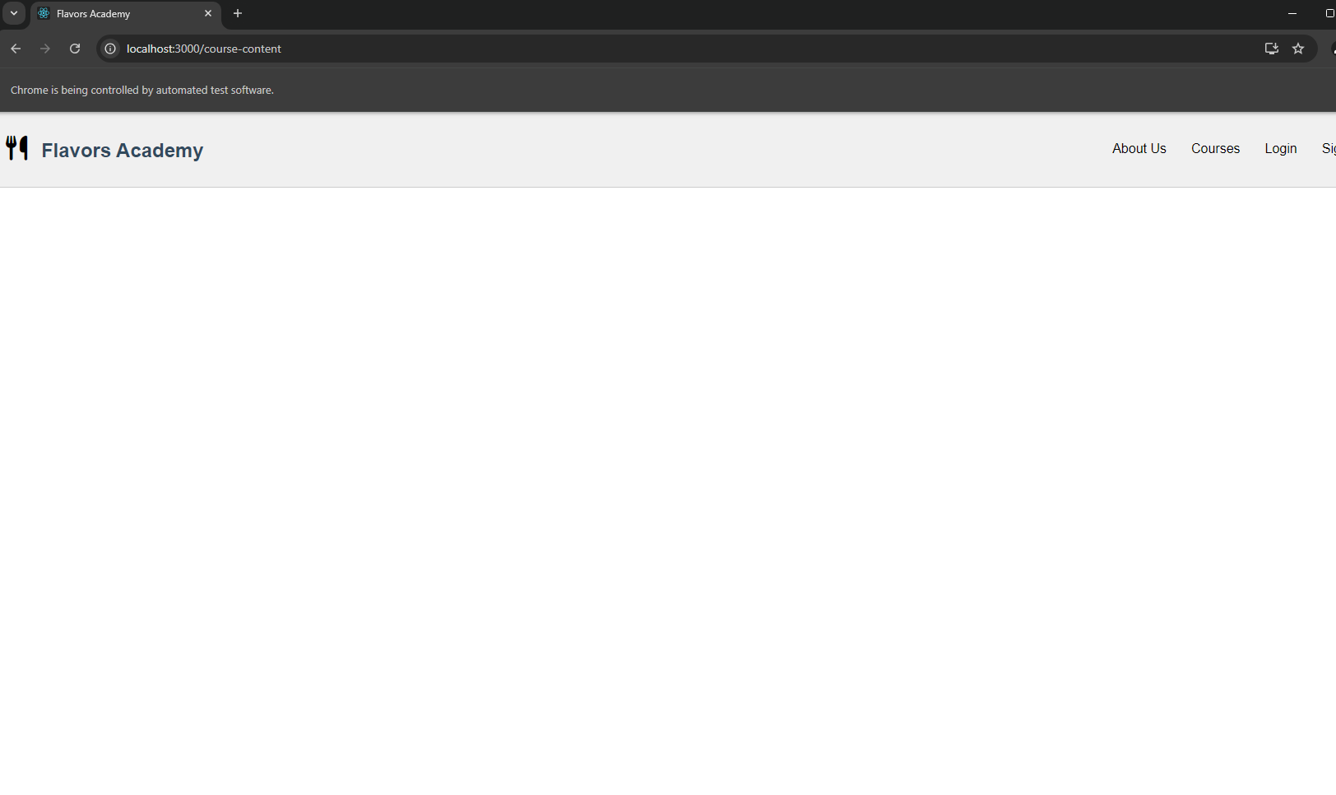

C:\CourseWork\code\flavors-academy-local\Testing\TestingFrontend>python test_teacher_courseContent.py

DevTools listening on ws://127.0.0.1:50460/devtools/browser/23bf62f9-619a-4078-b86c-cf0fae1646b8

[22836:24460:1119/185422.227:ERROR:device_event_log_impl.cc(201)] [18:54:22.228] USB: usb_service_win.cc:105 SetupDiGetDeviceProperty({{A45C254E-DF1C-4EFD-8020-67D146A850E0}, 6}) failed: Element not found. (0x490)

Created TensorFlow Lite XNNPACK delegate for CPU.

FFFFF

======================================================================

FAIL: test_add_edit_course_content (__main__.TestCourseContentComponent.test_add_edit_course_content)

----------------------------------------------------------------------

Traceback (most recent call last):

File "C:\CourseWork\code\flavors-academy-local\Testing\TestingFrontend\test_teacher_courseContent.py", line 87, in test_add_edit_course_content

add_content_button = WebDriverWait(driver, 15).until(

^^^^^^^^^^^^^^^^^^^^^^^^^^^^^^^^

File "C:\Users\Nishat.Sultana\AppData\Local\Packages\PythonSoftwareFoundation.Python.3.12_qbz5n2kfra8p0\LocalCache\local-packages\Python312\site-packages\selenium\webdriver\support\wait.py", line 105, in until

raise TimeoutException(message, screen, stacktrace)

selenium.common.exceptions.TimeoutException: Message:

Stacktrace:

GetHandleVerifier [0x003533E3+25059]

(No symbol) [0x002DCDE4]

(No symbol) [0x001BBEC3]

(No symbol) [0x001FFD86]

(No symbol) [0x001FFFCB]

(No symbol) [0x0023D952]

(No symbol) [0x00221F44]

(No symbol) [0x0023B51E]

(No symbol) [0x00221C96]

(No symbol) [0x001F3FAC]

(No symbol) [0x001F4F3D]

GetHandleVerifier [0x00645543+3113795]

GetHandleVerifier [0x0065A20A+3198986]

GetHandleVerifier [0x006529E2+3168226]

GetHandleVerifier [0x003F3250+680016]

(No symbol) [0x002E572D]

(No symbol) [0x002E29D8]

(No symbol) [0x002E2B75]

(No symbol) [0x002D57D0]

BaseThreadInitThunk [0x76BE7BA9+25]

RtlInitializeExceptionChain [0x77D2C0CB+107]

RtlClearBits [0x77D2C04F+191]

During handling of the above exception, another exception occurred:

Traceback (most recent call last):

File "C:\CourseWork\code\flavors-academy-local\Testing\TestingFrontend\test_teacher_courseContent.py", line 93, in test_add_edit_course_content

self.fail("Add Content button not found within wait time")

AssertionError: Add Content button not found within wait time

======================================================================

FAIL: test_add_edit_description_modal (__main__.TestCourseContentComponent.test_add_edit_description_modal)

----------------------------------------------------------------------

Traceback (most recent call last):

File "C:\CourseWork\code\flavors-academy-local\Testing\TestingFrontend\test_teacher_courseContent.py", line 33, in test_add_edit_description_modal

add_description_button = WebDriverWait(driver, 15).until(

^^^^^^^^^^^^^^^^^^^^^^^^^^^^^^^^

File "C:\Users\Nishat.Sultana\AppData\Local\Packages\PythonSoftwareFoundation.Python.3.12_qbz5n2kfra8p0\LocalCache\local-packages\Python312\site-packages\selenium\webdriver\support\wait.py", line 105, in until

raise TimeoutException(message, screen, stacktrace)

selenium.common.exceptions.TimeoutException: Message:

Stacktrace:

GetHandleVerifier [0x003533E3+25059]

(No symbol) [0x002DCDE4]

(No symbol) [0x001BBEC3]

(No symbol) [0x001FFD86]

(No symbol) [0x001FFFCB]

(No symbol) [0x0023D952]

(No symbol) [0x00221F44]

(No symbol) [0x0023B51E]

(No symbol) [0x00221C96]

(No symbol) [0x001F3FAC]

(No symbol) [0x001F4F3D]

GetHandleVerifier [0x00645543+3113795]

GetHandleVerifier [0x0065A20A+3198986]

GetHandleVerifier [0x006529E2+3168226]

GetHandleVerifier [0x003F3250+680016]

(No symbol) [0x002E572D]

(No symbol) [0x002E29D8]

(No symbol) [0x002E2B75]

(No symbol) [0x002D57D0]

BaseThreadInitThunk [0x76BE7BA9+25]

RtlInitializeExceptionChain [0x77D2C0CB+107]

RtlClearBits [0x77D2C04F+191]

During handling of the above exception, another exception occurred:

Traceback (most recent call last):

File "C:\CourseWork\code\flavors-academy-local\Testing\TestingFrontend\test_teacher_courseContent.py", line 39, in test_add_edit_description_modal

self.fail("Add Description button not found within wait time")

AssertionError: Add Description button not found within wait time

======================================================================

FAIL: test_rendering_initial_state (__main__.TestCourseContentComponent.test_rendering_initial_state)

----------------------------------------------------------------------

Traceback (most recent call last):

File "C:\CourseWork\code\flavors-academy-local\Testing\TestingFrontend\test_teacher_courseContent.py", line 20, in test_rendering_initial_state

main_title = WebDriverWait(driver, 15).until(

^^^^^^^^^^^^^^^^^^^^^^^^^^^^^^^^

File "C:\Users\Nishat.Sultana\AppData\Local\Packages\PythonSoftwareFoundation.Python.3.12_qbz5n2kfra8p0\LocalCache\local-packages\Python312\site-packages\selenium\webdriver\support\wait.py", line 105, in until

raise TimeoutException(message, screen, stacktrace)

selenium.common.exceptions.TimeoutException: Message:

Stacktrace:

GetHandleVerifier [0x003533E3+25059]

(No symbol) [0x002DCDE4]

(No symbol) [0x001BBEC3]

(No symbol) [0x001FFD86]

(No symbol) [0x001FFFCB]

(No symbol) [0x0023D952]

(No symbol) [0x00221F44]

(No symbol) [0x0023B51E]

(No symbol) [0x00221C96]

(No symbol) [0x001F3FAC]

(No symbol) [0x001F4F3D]

GetHandleVerifier [0x00645543+3113795]

GetHandleVerifier [0x0065A20A+3198986]

GetHandleVerifier [0x006529E2+3168226]

GetHandleVerifier [0x003F3250+680016]

(No symbol) [0x002E572D]

(No symbol) [0x002E29D8]

(No symbol) [0x002E2B75]

(No symbol) [0x002D57D0]

BaseThreadInitThunk [0x76BE7BA9+25]

RtlInitializeExceptionChain [0x77D2C0CB+107]

RtlClearBits [0x77D2C04F+191]

During handling of the above exception, another exception occurred:

Traceback (most recent call last):

File "C:\CourseWork\code\flavors-academy-local\Testing\TestingFrontend\test_teacher_courseContent.py", line 26, in test_rendering_initial_state

self.fail("Main title (Flavors Academy) did not load as expected")

AssertionError: Main title (Flavors Academy) did not load as expected

======================================================================

FAIL: test_success_message_disappears (__main__.TestCourseContentComponent.test_success_message_disappears)

----------------------------------------------------------------------

Traceback (most recent call last):

File "C:\CourseWork\code\flavors-academy-local\Testing\TestingFrontend\test_teacher_courseContent.py", line 121, in test_success_message_disappears

upload_button = WebDriverWait(driver, 15).until(

^^^^^^^^^^^^^^^^^^^^^^^^^^^^^^^^

File "C:\Users\Nishat.Sultana\AppData\Local\Packages\PythonSoftwareFoundation.Python.3.12_qbz5n2kfra8p0\LocalCache\local-packages\Python312\site-packages\selenium\webdriver\support\wait.py", line 105, in until

raise TimeoutException(message, screen, stacktrace)

selenium.common.exceptions.TimeoutException: Message:

Stacktrace:

GetHandleVerifier [0x003533E3+25059]

(No symbol) [0x002DCDE4]

(No symbol) [0x001BBEC3]

(No symbol) [0x001FFD86]

(No symbol) [0x001FFFCB]

(No symbol) [0x0023D952]

(No symbol) [0x00221F44]

(No symbol) [0x0023B51E]

(No symbol) [0x00221C96]

(No symbol) [0x001F3FAC]

(No symbol) [0x001F4F3D]

GetHandleVerifier [0x00645543+3113795]

GetHandleVerifier [0x0065A20A+3198986]

GetHandleVerifier [0x006529E2+3168226]

GetHandleVerifier [0x003F3250+680016]

(No symbol) [0x002E572D]

(No symbol) [0x002E29D8]

(No symbol) [0x002E2B75]

(No symbol) [0x002D57D0]

BaseThreadInitThunk [0x76BE7BA9+25]

RtlInitializeExceptionChain [0x77D2C0CB+107]

RtlClearBits [0x77D2C04F+191]

During handling of the above exception, another exception occurred:

Traceback (most recent call last):

File "C:\CourseWork\code\flavors-academy-local\Testing\TestingFrontend\test_teacher_courseContent.py", line 134, in test_success_message_disappears

self.fail("Success message did not appear or disappear as expected")

AssertionError: Success message did not appear or disappear as expected

======================================================================

FAIL: test_upload_replace_syllabus (__main__.TestCourseContentComponent.test_upload_replace_syllabus)

----------------------------------------------------------------------

Traceback (most recent call last):

File "C:\CourseWork\code\flavors-academy-local\Testing\TestingFrontend\test_teacher_courseContent.py", line 65, in test_upload_replace_syllabus

upload_button = WebDriverWait(driver, 15).until(

^^^^^^^^^^^^^^^^^^^^^^^^^^^^^^^^

File "C:\Users\Nishat.Sultana\AppData\Local\Packages\PythonSoftwareFoundation.Python.3.12_qbz5n2kfra8p0\LocalCache\local-packages\Python312\site-packages\selenium\webdriver\support\wait.py", line 105, in until

raise TimeoutException(message, screen, stacktrace)

selenium.common.exceptions.TimeoutException: Message:

Stacktrace:

GetHandleVerifier [0x003533E3+25059]

(No symbol) [0x002DCDE4]

(No symbol) [0x001BBEC3]

(No symbol) [0x001FFD86]

(No symbol) [0x001FFFCB]

(No symbol) [0x0023D952]

(No symbol) [0x00221F44]

(No symbol) [0x0023B51E]

(No symbol) [0x00221C96]

(No symbol) [0x001F3FAC]

(No symbol) [0x001F4F3D]

GetHandleVerifier [0x00645543+3113795]

GetHandleVerifier [0x0065A20A+3198986]

GetHandleVerifier [0x006529E2+3168226]

GetHandleVerifier [0x003F3250+680016]

(No symbol) [0x002E572D]

(No symbol) [0x002E29D8]

(No symbol) [0x002E2B75]

(No symbol) [0x002D57D0]

BaseThreadInitThunk [0x76BE7BA9+25]

RtlInitializeExceptionChain [0x77D2C0CB+107]

RtlClearBits [0x77D2C04F+191]

During handling of the above exception, another exception occurred:

Traceback (most recent call last):

File "C:\CourseWork\code\flavors-academy-local\Testing\TestingFrontend\test_teacher_courseContent.py", line 71, in test_upload_replace_syllabus

self.fail("Upload Syllabus button not found within wait time")

AssertionError: Upload Syllabus button not found within wait time

----------------------------------------------------------------------

Ran 5 tests in 83.159s

FAILED (failures=5)  
  
test_uploadModal

C:\CourseWork\code\flavors-academy-local\Testing\TestingFrontend>python test_uploadModal.py

DevTools listening on ws://127.0.0.1:50722/devtools/browser/f8789302-20cd-4cdd-873f-4e741aab4f07

[4804:25020:1119/185620.617:ERROR:device_event_log_impl.cc(201)] [18:56:20.616] USB: usb_service_win.cc:105 SetupDiGetDeviceProperty({{A45C254E-DF1C-4EFD-8020-67D146A850E0}, 6}) failed: Element not found. (0x490)

FCreated TensorFlow Lite XNNPACK delegate for CPU.

F

======================================================================

FAIL: test_cancel_button (__main__.TestUploadModal.test_cancel_button)

----------------------------------------------------------------------

Traceback (most recent call last):

File "C:\CourseWork\code\flavors-academy-local\Testing\TestingFrontend\test_uploadModal.py", line 59, in test_cancel_button

cancel_button = WebDriverWait(driver, 10).until(

^^^^^^^^^^^^^^^^^^^^^^^^^^^^^^^^

File "C:\Users\Nishat.Sultana\AppData\Local\Packages\PythonSoftwareFoundation.Python.3.12_qbz5n2kfra8p0\LocalCache\local-packages\Python312\site-packages\selenium\webdriver\support\wait.py", line 105, in until

raise TimeoutException(message, screen, stacktrace)

selenium.common.exceptions.TimeoutException: Message:

Stacktrace:

GetHandleVerifier [0x003533E3+25059]

(No symbol) [0x002DCDE4]

(No symbol) [0x001BBEC3]

(No symbol) [0x001FFD86]

(No symbol) [0x001FFFCB]

(No symbol) [0x0023D952]

(No symbol) [0x00221F44]

(No symbol) [0x0023B51E]

(No symbol) [0x00221C96]

(No symbol) [0x001F3FAC]

(No symbol) [0x001F4F3D]

GetHandleVerifier [0x00645543+3113795]

GetHandleVerifier [0x0065A20A+3198986]

GetHandleVerifier [0x006529E2+3168226]

GetHandleVerifier [0x003F3250+680016]

(No symbol) [0x002E572D]

(No symbol) [0x002E29D8]

(No symbol) [0x002E2B75]

(No symbol) [0x002D57D0]

BaseThreadInitThunk [0x76BE7BA9+25]

RtlInitializeExceptionChain [0x77D2C0CB+107]

RtlClearBits [0x77D2C04F+191]

During handling of the above exception, another exception occurred:

Traceback (most recent call last):

File "C:\CourseWork\code\flavors-academy-local\Testing\TestingFrontend\test_uploadModal.py", line 69, in test_cancel_button

self.fail("Cancel button did not close the modal as expected.")

AssertionError: Cancel button did not close the modal as expected.

======================================================================

FAIL: test_file_selection_and_upload (__main__.TestUploadModal.test_file_selection_and_upload)

----------------------------------------------------------------------

Traceback (most recent call last):

File "C:\CourseWork\code\flavors-academy-local\Testing\TestingFrontend\test_uploadModal.py", line 27, in test_file_selection_and_upload

file_input = WebDriverWait(driver, 10).until(

^^^^^^^^^^^^^^^^^^^^^^^^^^^^^^^^

File "C:\Users\Nishat.Sultana\AppData\Local\Packages\PythonSoftwareFoundation.Python.3.12_qbz5n2kfra8p0\LocalCache\local-packages\Python312\site-packages\selenium\webdriver\support\wait.py", line 105, in until

raise TimeoutException(message, screen, stacktrace)

selenium.common.exceptions.TimeoutException: Message:

Stacktrace:

GetHandleVerifier [0x003533E3+25059]

(No symbol) [0x002DCDE4]

(No symbol) [0x001BBEC3]

(No symbol) [0x001FFD86]

(No symbol) [0x001FFFCB]

(No symbol) [0x0023D952]

(No symbol) [0x00221F44]

(No symbol) [0x0023B51E]

(No symbol) [0x00221C96]

(No symbol) [0x001F3FAC]

(No symbol) [0x001F4F3D]

GetHandleVerifier [0x00645543+3113795]

GetHandleVerifier [0x0065A20A+3198986]

GetHandleVerifier [0x006529E2+3168226]

GetHandleVerifier [0x003F3250+680016]

(No symbol) [0x002E572D]

(No symbol) [0x002E29D8]

(No symbol) [0x002E2B75]

(No symbol) [0x002D57D0]

BaseThreadInitThunk [0x76BE7BA9+25]

RtlInitializeExceptionChain [0x77D2C0CB+107]

RtlClearBits [0x77D2C04F+191]

During handling of the above exception, another exception occurred:

Traceback (most recent call last):

File "C:\CourseWork\code\flavors-academy-local\Testing\TestingFrontend\test_uploadModal.py", line 52, in test_file_selection_and_upload

self.fail("File selection or upload progress not working as expected.")

AssertionError: File selection or upload progress not working as expected.

----------------------------------------------------------------------

Ran 2 tests in 27.493s

FAILED (failures=2)  
  
test_addContent

C:\CourseWork\code\flavors-academy-local\Testing\TestingFrontend>python test_uploadModal.py

DevTools listening on ws://127.0.0.1:50722/devtools/browser/f8789302-20cd-4cdd-873f-4e741aab4f07

[4804:25020:1119/185620.617:ERROR:device_event_log_impl.cc(201)] [18:56:20.616] USB: usb_service_win.cc:105 SetupDiGetDeviceProperty({{A45C254E-DF1C-4EFD-8020-67D146A850E0}, 6}) failed: Element not found. (0x490)

FCreated TensorFlow Lite XNNPACK delegate for CPU.

F

======================================================================

FAIL: test_cancel_button (__main__.TestUploadModal.test_cancel_button)

----------------------------------------------------------------------

Traceback (most recent call last):

File "C:\CourseWork\code\flavors-academy-local\Testing\TestingFrontend\test_uploadModal.py", line 59, in test_cancel_button

cancel_button = WebDriverWait(driver, 10).until(

^^^^^^^^^^^^^^^^^^^^^^^^^^^^^^^^

File "C:\Users\Nishat.Sultana\AppData\Local\Packages\PythonSoftwareFoundation.Python.3.12_qbz5n2kfra8p0\LocalCache\local-packages\Python312\site-packages\selenium\webdriver\support\wait.py", line 105, in until

raise TimeoutException(message, screen, stacktrace)

selenium.common.exceptions.TimeoutException: Message:

Stacktrace:

GetHandleVerifier [0x003533E3+25059]

(No symbol) [0x002DCDE4]

(No symbol) [0x001BBEC3]

(No symbol) [0x001FFD86]

(No symbol) [0x001FFFCB]

(No symbol) [0x0023D952]

(No symbol) [0x00221F44]

(No symbol) [0x0023B51E]

(No symbol) [0x00221C96]

(No symbol) [0x001F3FAC]

(No symbol) [0x001F4F3D]

GetHandleVerifier [0x00645543+3113795]

GetHandleVerifier [0x0065A20A+3198986]

GetHandleVerifier [0x006529E2+3168226]

GetHandleVerifier [0x003F3250+680016]

(No symbol) [0x002E572D]

(No symbol) [0x002E29D8]

(No symbol) [0x002E2B75]

(No symbol) [0x002D57D0]

BaseThreadInitThunk [0x76BE7BA9+25]

RtlInitializeExceptionChain [0x77D2C0CB+107]

RtlClearBits [0x77D2C04F+191]

During handling of the above exception, another exception occurred:

Traceback (most recent call last):

File "C:\CourseWork\code\flavors-academy-local\Testing\TestingFrontend\test_uploadModal.py", line 69, in test_cancel_button

self.fail("Cancel button did not close the modal as expected.")

AssertionError: Cancel button did not close the modal as expected.

======================================================================

FAIL: test_file_selection_and_upload (__main__.TestUploadModal.test_file_selection_and_upload)

----------------------------------------------------------------------

Traceback (most recent call last):

File "C:\CourseWork\code\flavors-academy-local\Testing\TestingFrontend\test_uploadModal.py", line 27, in test_file_selection_and_upload

file_input = WebDriverWait(driver, 10).until(

^^^^^^^^^^^^^^^^^^^^^^^^^^^^^^^^

File "C:\Users\Nishat.Sultana\AppData\Local\Packages\PythonSoftwareFoundation.Python.3.12_qbz5n2kfra8p0\LocalCache\local-packages\Python312\site-packages\selenium\webdriver\support\wait.py", line 105, in until

raise TimeoutException(message, screen, stacktrace)

selenium.common.exceptions.TimeoutException: Message:

Stacktrace:

GetHandleVerifier [0x003533E3+25059]

(No symbol) [0x002DCDE4]

(No symbol) [0x001BBEC3]

(No symbol) [0x001FFD86]

(No symbol) [0x001FFFCB]

(No symbol) [0x0023D952]

(No symbol) [0x00221F44]

(No symbol) [0x0023B51E]

(No symbol) [0x00221C96]

(No symbol) [0x001F3FAC]

(No symbol) [0x001F4F3D]

GetHandleVerifier [0x00645543+3113795]

GetHandleVerifier [0x0065A20A+3198986]

GetHandleVerifier [0x006529E2+3168226]

GetHandleVerifier [0x003F3250+680016]

(No symbol) [0x002E572D]

(No symbol) [0x002E29D8]

(No symbol) [0x002E2B75]

(No symbol) [0x002D57D0]

BaseThreadInitThunk [0x76BE7BA9+25]

RtlInitializeExceptionChain [0x77D2C0CB+107]

RtlClearBits [0x77D2C04F+191]

During handling of the above exception, another exception occurred:

Traceback (most recent call last):

File "C:\CourseWork\code\flavors-academy-local\Testing\TestingFrontend\test_uploadModal.py", line 52, in test_file_selection_and_upload

self.fail("File selection or upload progress not working as expected.")

AssertionError: File selection or upload progress not working as expected.

----------------------------------------------------------------------

Ran 2 tests in 27.493s

FAILED (failures=2)

C:\CourseWork\code\flavors-academy-local\Testing\TestingFrontend>python test_addContentModal.py

DevTools listening on ws://127.0.0.1:50795/devtools/browser/4fbe3336-08c0-4858-a2ad-39bd7da125df

[10768:25592:1119/185746.114:ERROR:device_event_log_impl.cc(201)] [18:57:46.114] USB: usb_service_win.cc:105 SetupDiGetDeviceProperty({{A45C254E-DF1C-4EFD-8020-67D146A850E0}, 6}) failed: Element not found. (0x490)

FCreated TensorFlow Lite XNNPACK delegate for CPU.

FFFF

======================================================================

FAIL: test_assignment_upload_progress (__main__.TestAddContentModal.test_assignment_upload_progress)

----------------------------------------------------------------------

Traceback (most recent call last):

File "C:\CourseWork\code\flavors-academy-local\Testing\TestingFrontend\test_addContentModal.py", line 95, in test_assignment_upload_progress

assignment_input = WebDriverWait(driver, 10).until(

^^^^^^^^^^^^^^^^^^^^^^^^^^^^^^^^

File "C:\Users\Nishat.Sultana\AppData\Local\Packages\PythonSoftwareFoundation.Python.3.12_qbz5n2kfra8p0\LocalCache\local-packages\Python312\site-packages\selenium\webdriver\support\wait.py", line 105, in until

raise TimeoutException(message, screen, stacktrace)

selenium.common.exceptions.TimeoutException: Message:

Stacktrace:

GetHandleVerifier [0x003533E3+25059]

(No symbol) [0x002DCDE4]

(No symbol) [0x001BBEC3]

(No symbol) [0x001FFD86]

(No symbol) [0x001FFFCB]

(No symbol) [0x0023D952]

(No symbol) [0x00221F44]

(No symbol) [0x0023B51E]

(No symbol) [0x00221C96]

(No symbol) [0x001F3FAC]

(No symbol) [0x001F4F3D]

GetHandleVerifier [0x00645543+3113795]

GetHandleVerifier [0x0065A20A+3198986]

GetHandleVerifier [0x006529E2+3168226]

GetHandleVerifier [0x003F3250+680016]

(No symbol) [0x002E572D]

(No symbol) [0x002E29D8]

(No symbol) [0x002E2B75]

(No symbol) [0x002D57D0]

BaseThreadInitThunk [0x76BE7BA9+25]

RtlInitializeExceptionChain [0x77D2C0CB+107]

RtlClearBits [0x77D2C04F+191]

During handling of the above exception, another exception occurred:

Traceback (most recent call last):

File "C:\CourseWork\code\flavors-academy-local\Testing\TestingFrontend\test_addContentModal.py", line 110, in test_assignment_upload_progress

self.fail("Assignment upload or progress display failed.")

AssertionError: Assignment upload or progress display failed.

======================================================================

FAIL: test_cancel_button (__main__.TestAddContentModal.test_cancel_button)

----------------------------------------------------------------------

Traceback (most recent call last):

File "C:\CourseWork\code\flavors-academy-local\Testing\TestingFrontend\test_addContentModal.py", line 117, in test_cancel_button

cancel_button = WebDriverWait(driver, 10).until(

^^^^^^^^^^^^^^^^^^^^^^^^^^^^^^^^

File "C:\Users\Nishat.Sultana\AppData\Local\Packages\PythonSoftwareFoundation.Python.3.12_qbz5n2kfra8p0\LocalCache\local-packages\Python312\site-packages\selenium\webdriver\support\wait.py", line 105, in until

raise TimeoutException(message, screen, stacktrace)

selenium.common.exceptions.TimeoutException: Message:

Stacktrace:

GetHandleVerifier [0x003533E3+25059]

(No symbol) [0x002DCDE4]

(No symbol) [0x001BBEC3]

(No symbol) [0x001FFD86]

(No symbol) [0x001FFFCB]

(No symbol) [0x0023D952]

(No symbol) [0x00221F44]

(No symbol) [0x0023B51E]

(No symbol) [0x00221C96]

(No symbol) [0x001F3FAC]

(No symbol) [0x001F4F3D]

GetHandleVerifier [0x00645543+3113795]

GetHandleVerifier [0x0065A20A+3198986]

GetHandleVerifier [0x006529E2+3168226]

GetHandleVerifier [0x003F3250+680016]

(No symbol) [0x002E572D]

(No symbol) [0x002E29D8]

(No symbol) [0x002E2B75]

(No symbol) [0x002D57D0]

BaseThreadInitThunk [0x76BE7BA9+25]

RtlInitializeExceptionChain [0x77D2C0CB+107]

RtlClearBits [0x77D2C04F+191]

During handling of the above exception, another exception occurred:

Traceback (most recent call last):

File "C:\CourseWork\code\flavors-academy-local\Testing\TestingFrontend\test_addContentModal.py", line 127, in test_cancel_button

self.fail("Cancel button did not close the modal.")

AssertionError: Cancel button did not close the modal.

======================================================================

FAIL: test_file_upload_progress (__main__.TestAddContentModal.test_file_upload_progress)

----------------------------------------------------------------------

Traceback (most recent call last):

File "C:\CourseWork\code\flavors-academy-local\Testing\TestingFrontend\test_addContentModal.py", line 49, in test_file_upload_progress

file_input = WebDriverWait(driver, 10).until(

^^^^^^^^^^^^^^^^^^^^^^^^^^^^^^^^

File "C:\Users\Nishat.Sultana\AppData\Local\Packages\PythonSoftwareFoundation.Python.3.12_qbz5n2kfra8p0\LocalCache\local-packages\Python312\site-packages\selenium\webdriver\support\wait.py", line 105, in until

raise TimeoutException(message, screen, stacktrace)

selenium.common.exceptions.TimeoutException: Message:

Stacktrace:

GetHandleVerifier [0x003533E3+25059]

(No symbol) [0x002DCDE4]

(No symbol) [0x001BBEC3]

(No symbol) [0x001FFD86]

(No symbol) [0x001FFFCB]

(No symbol) [0x0023D952]

(No symbol) [0x00221F44]

(No symbol) [0x0023B51E]

(No symbol) [0x00221C96]

(No symbol) [0x001F3FAC]

(No symbol) [0x001F4F3D]

GetHandleVerifier [0x00645543+3113795]

GetHandleVerifier [0x0065A20A+3198986]

GetHandleVerifier [0x006529E2+3168226]

GetHandleVerifier [0x003F3250+680016]

(No symbol) [0x002E572D]

(No symbol) [0x002E29D8]

(No symbol) [0x002E2B75]

(No symbol) [0x002D57D0]

BaseThreadInitThunk [0x76BE7BA9+25]

RtlInitializeExceptionChain [0x77D2C0CB+107]

RtlClearBits [0x77D2C04F+191]

During handling of the above exception, another exception occurred:

Traceback (most recent call last):

File "C:\CourseWork\code\flavors-academy-local\Testing\TestingFrontend\test_addContentModal.py", line 64, in test_file_upload_progress

self.fail("File upload or progress display failed.")

AssertionError: File upload or progress display failed.

======================================================================

FAIL: test_fill_form_and_save (__main__.TestAddContentModal.test_fill_form_and_save)

----------------------------------------------------------------------

Traceback (most recent call last):

File "C:\CourseWork\code\flavors-academy-local\Testing\TestingFrontend\test_addContentModal.py", line 22, in test_fill_form_and_save

content_no_input = WebDriverWait(driver, 10).until(

^^^^^^^^^^^^^^^^^^^^^^^^^^^^^^^^

File "C:\Users\Nishat.Sultana\AppData\Local\Packages\PythonSoftwareFoundation.Python.3.12_qbz5n2kfra8p0\LocalCache\local-packages\Python312\site-packages\selenium\webdriver\support\wait.py", line 105, in until

raise TimeoutException(message, screen, stacktrace)

selenium.common.exceptions.TimeoutException: Message:

Stacktrace:

GetHandleVerifier [0x003533E3+25059]

(No symbol) [0x002DCDE4]

(No symbol) [0x001BBEC3]

(No symbol) [0x001FFD86]

(No symbol) [0x001FFFCB]

(No symbol) [0x0023D952]

(No symbol) [0x00221F44]

(No symbol) [0x0023B51E]

(No symbol) [0x00221C96]

(No symbol) [0x001F3FAC]

(No symbol) [0x001F4F3D]

GetHandleVerifier [0x00645543+3113795]

GetHandleVerifier [0x0065A20A+3198986]

GetHandleVerifier [0x006529E2+3168226]

GetHandleVerifier [0x003F3250+680016]

(No symbol) [0x002E572D]

(No symbol) [0x002E29D8]

(No symbol) [0x002E2B75]

(No symbol) [0x002D57D0]

BaseThreadInitThunk [0x76BE7BA9+25]

RtlInitializeExceptionChain [0x77D2C0CB+107]

RtlClearBits [0x77D2C04F+191]

During handling of the above exception, another exception occurred:

Traceback (most recent call last):

File "C:\CourseWork\code\flavors-academy-local\Testing\TestingFrontend\test_addContentModal.py", line 41, in test_fill_form_and_save

self.fail("Failed to find and fill form fields.")

AssertionError: Failed to find and fill form fields.

======================================================================

FAIL: test_video_upload_progress (__main__.TestAddContentModal.test_video_upload_progress)

----------------------------------------------------------------------

Traceback (most recent call last):

File "C:\CourseWork\code\flavors-academy-local\Testing\TestingFrontend\test_addContentModal.py", line 72, in test_video_upload_progress

video_input = WebDriverWait(driver, 10).until(

^^^^^^^^^^^^^^^^^^^^^^^^^^^^^^^^

File "C:\Users\Nishat.Sultana\AppData\Local\Packages\PythonSoftwareFoundation.Python.3.12_qbz5n2kfra8p0\LocalCache\local-packages\Python312\site-packages\selenium\webdriver\support\wait.py", line 105, in until

raise TimeoutException(message, screen, stacktrace)

selenium.common.exceptions.TimeoutException: Message:

Stacktrace:

GetHandleVerifier [0x003533E3+25059]

(No symbol) [0x002DCDE4]

(No symbol) [0x001BBEC3]

(No symbol) [0x001FFD86]

(No symbol) [0x001FFFCB]

(No symbol) [0x0023D952]

(No symbol) [0x00221F44]

(No symbol) [0x0023B51E]

(No symbol) [0x00221C96]

(No symbol) [0x001F3FAC]

(No symbol) [0x001F4F3D]

GetHandleVerifier [0x00645543+3113795]

GetHandleVerifier [0x0065A20A+3198986]

GetHandleVerifier [0x006529E2+3168226]

GetHandleVerifier [0x003F3250+680016]

(No symbol) [0x002E572D]

(No symbol) [0x002E29D8]

(No symbol) [0x002E2B75]

(No symbol) [0x002D57D0]

BaseThreadInitThunk [0x76BE7BA9+25]

RtlInitializeExceptionChain [0x77D2C0CB+107]

RtlClearBits [0x77D2C04F+191]

During handling of the above exception, another exception occurred:

Traceback (most recent call last):

File "C:\CourseWork\code\flavors-academy-local\Testing\TestingFrontend\test_addContentModal.py", line 87, in test_video_upload_progress

self.fail("Video upload or progress display failed.")

AssertionError: Video upload or progress display failed.

----------------------------------------------------------------------

Ran 5 tests in 58.245s

FAILED (failures=5)

Test Services

C:\CourseWork\code\flavors-academy-local\Testing\TestingFrontend>python test_service.py

.........

----------------------------------------------------------------------

Ran 9 tests in 0.006s

OK